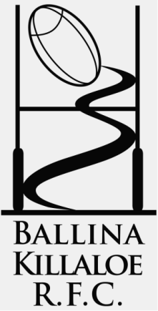
Ballina-Killaloe R.F.C.
www.ballinakillaloerfc.com

Order form BK RFC branded gear

Clothing | Price € | Quantity | Age,Size & Height | Total
Package deal – Zip Top, Skinny pants, T-Shirt | 55.00
¼ Zip top | 30.00
Skinny pants | 25.00
T-Shirt | 18.00
Beanie(in Stock) | 10.00
Rugby shorts | 18.00
Socks | 8.00
Waterproof Training Top | 30.00
 |  |  | Overall Total
Please return to your coach with full payment by 5th March
Name | Contact Number | email
Player Name………………………………………….
Size Chart -approximate sizes only
size | XSB | SB | MB | LB | XLB | YXS | SY | MY | LY | XLY | XS | S | M | L | XL | XXL
Approx. Age | 7-8 | 8-9 | 9-10 | 11 | 12+ | 9 | 10 | 12 | 13 | 14+ | adult

